CTM-I Use Case

Futures Trade Release

Version 0.1

Use Case Name | Futures Trade Release
Actor | One Chicago Firm, Market Operations, Operations, App Support
Pre-conditions /Assumptions | User has Browser and is aware of the http path to the application.  User has successfully logged into the CTM-I application.  User has selected a specific trade to release from the Futures Trade Query.
Post Conditions | None
Screenshot | 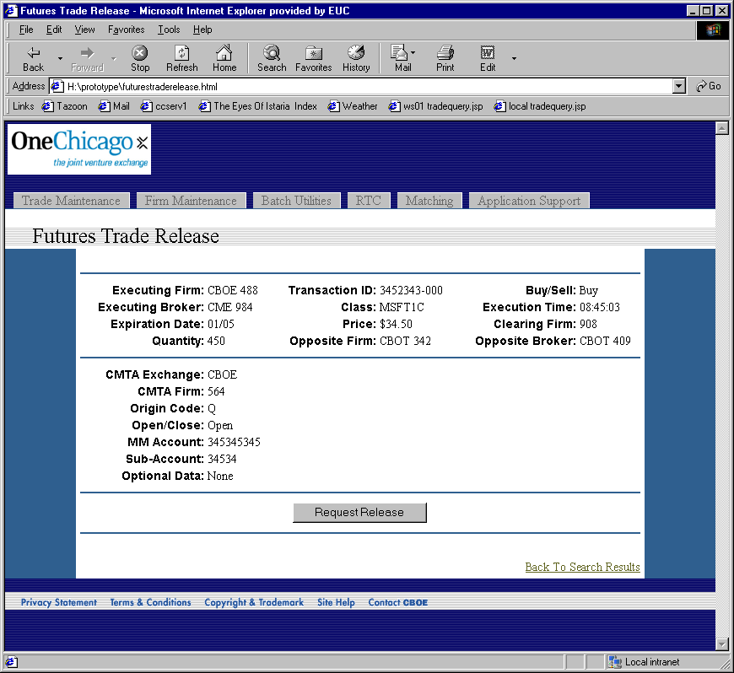
Flow of Events | - Futures Trade Release screen displays for the trade requested.  - The following fields display with the information from the trade.  - Executing Firm – Display firm exchange and number  - Executing Broker – Display broker exchange and broker  - Expiration Date  - Quantity  - Transaction ID  - Class  - Price  - Opposite Firm – Display firm exchange and number  - Buy/Sell  - Execution Time  - Clearing Firm – Display firm exchange and number  - Opposite Broker – Display broker exchange and broker  - CMTA Exchange  - CMTA Firm  - Origin Code  - Open/Close  - Market Maker Account  - Sub-Account  - Optional Data.  - User can press the “Accept Release”/“Request Release” button to request a release of this trade.  - The trade is sent to CTM-R to request a release.  - Once CTM-R successfully releases the trade, the user is returned to the search results screen, Use Case Futures Trade Query. The last set of criteria used by the user should be used to perform the search and display the results.
Alternative Path | 1.1 If the selected trade is the opposite side of a trade that has already had a release requested, the button will display “Accept Release” instead of “Request Release”.

